**ELECTRIC FORCE**

**Electrostatics**

* Branch of physics that deals with the study of charges at rest

**Electric Charges**

* one of the basic properties of the elementary particles of matter giving rise to all electric and magnetic forces and interactions.
* There are two types of **electric charges**: positive and negative.

|  |  |  |
| --- | --- | --- |
| **Particle** | **Charge** | **Mass (kg)** |
| Electron (e) | -1.6 x 10-19 C or -4.8 x 10-10 esu (or statC) | 9.1094 x 10-31 |
| Proton (p) | +1.6 x 10-19 C or +4.8 x 10-10 esu (or statC) | 1.6726 x 10-27 |
| Neutron (n) | 0 | 1.6749 x 10-27 |

Atomic Structure:

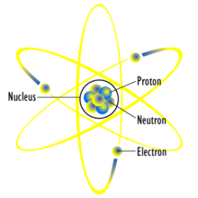

* 1C = 3 x 109 statC

**Electron Theory:**

1. A neutral body is one that has exactly as many electrons as there are protons.
2. When a neutral body gains electrons from an outside source, it acquires a negative charge.

Hence, a negatively charged body has more electrons than protons.

1. When neutral body loses some of its own electrons, it acquires a positive charge.

Hence, a positively charged body has fewer electrons than protons.

Electrification (Charging of Body):

* The process of gaining or losing electron (transfer of electrons from one material to the other)

Two Methods of Electrification:

1. Conduction

* charging a neutral body by bringing into contact with a charged body

1. Induction

* The charging body is brought near the neutral body, thus inducing it to have an opposite charge as that of the charging body.

Laws of Electrostatics:

1. Like charges repel, unlike charges attract each other
2. Law of Conservation of Charge

* The algebraic sum of the electric charge in any closed system remains constant

1. Coulomb’s Law of Electrostatics (Charles Augustin de Coulomb)

* The force F between two electric charges is directly proportional to the product of the charges and inversely proportional to the square of the distance between them.

**Coulomb’s Law**

**F = k $\frac{{|q}_{1}||q_{2}|}{r^{2}}$** Where: F = force between the charges; N or dynes

q1 & q2 = magnitude of the charges; C or esu (or statC)

r = distance between them; m or cm

k = constant of proportionality (depending on

**k = $\frac{1}{4πε}$**  ; where ε = permittivity of the medium

***For air***: $ε$ = 8.85 x 10-12 C2/N-m2

k = 9 x 109 N-m2/C2

= 1 dyne-cm2/esu2

**ELECTRIC FIELD**

* Portions of space surrounding the charged body or several charged bodies
* Line of force
* an imaginary line representing a field of force, such as an electric field, such that the tangent at any point is the direction of the field vector at that point
* Direction of an Electric Field lines:
* Electric field lines are directed away from positive charges and *toward* negative charges.

Two equal and opposite charges (a dipole)

A single positive charge

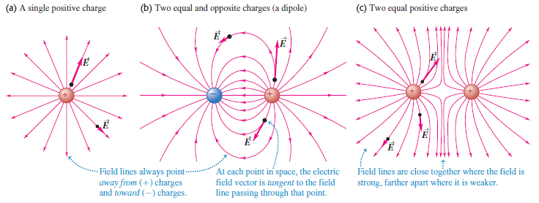

Field lines always point *away from* (+) charges and *toward* (-) charges.

At each point in space, the electric field vector is *tangent* to the field line passing through that point.

Field lines are close together where the field is strong, farther apart where it is weaker.

**\*** E is a vector quantity. Its direction is the same as the direction of the force that acts on a + charge placed at that point.

The **Electric Field, *E*** at some point in space is defined as the electric force ***F*** that acts on a small positive test charge, *q0*, placed at that point divided by the magnitude of the test charge:

Ep = $\frac{F}{q_{0}}$ since F = k $\frac{qq_{0}}{r^{2}}$

**Ep = k $\frac{|q|}{r^{2}}$** N/C or dyne/esu

**ELECTRIC POTENTIAL**

**ELECTRIC POTENTIAL ENERGY (U)**

Electric potential energy is a potential energy (measured in joules) that results from conservative Coulomb forces and is associated with the configuration of a particular set of point charges within a defined system.

The **potential energy** associated with two point charges q1 and q2 separated by a distance r12 is

****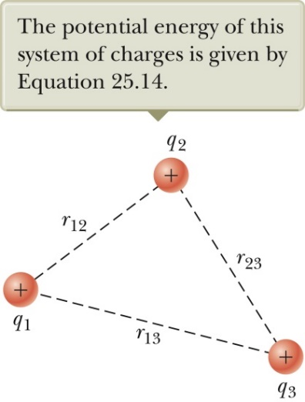

*Energy is a scalar*, not a vector. To find the total electric potential energy associated with a set of charges, simply add up the energy (*which may be positive or negative*) associated with each pair of charges.

$$U=k\frac{q_{1}q_{2}}{r_{12}}+k\frac{q_{1}q_{3}}{r_{13}}+k\frac{q_{2}q_{3}}{r_{23}}$$

***Work-Energy Principle***

The change in electric potential energy, ΔU = UB – UA when a point charge ‘*q’* moves from some point ‘*A’* to another point ‘*B’*, is the *negative of the work done by the internal force (conservative force, i.e., electric force and field ) or the positive of the work done by an external or applied force (non-conservative force),* as the charge moves from ‘*A’* to ‘*B’*.

**-Winternal = ΔU = Ub – Ua**

**Wextenal** **= ΔU = Ub – Ua**

**Wexternal = -Winternal**

**ELECTRIC POTENTIAL (V)** at a point:

* potential energy *U per unit charge* associated with a test charge *q* placed at that point

$$Vp=\frac{U}{q}=\frac{kQ}{r} ,\frac{Joules}{Coulomb}or Volts$$

where: Vp = electric potential at the point ‘P’

r = distance between the point charge Q and a test charge q located at a certain point ‘P’

k = proportionality constant

**\*NOTE: Vp is (+) if Q (+); Vp is (-) if Q (-)**

**POTENTIAL DUE TO A COLLECTION OF POINT CHARGES (Q1, Q2, Q3, …):**

* the electric potential due to a collection of point charges is the ***scalar (algebraic)* sum** of the potentials due to each charge.

**VTOT. = + + + . . . = k $\sum{\frac{Q_{i}}{r_{i}}}$**

**POTENTIAL DIFFERENCE, ΔV**

The potential difference ***ΔV = VB - VA*** between two points ***A*** and ***B*** in an electric field is defined as the change in electric potential energy of the system when a charge q is moved between the points divided by the charge:

$$∆V=V_{B}- V_{A}= \frac{∆U}{q} = -\frac{W_{int}}{q}= \frac{W_{ext}}{q}$$

* For ***conservative/internal force*** (i.e. electric force and field): $W_{int., A→B}$ (*from A to B*) **= - *(VB - VA)(q)***
* For ***non-conservative force*** (i.e external/applied force): $W_{ext., A→B}$ (*from A to B*) **= *(VB - VA)(q)***

Problems:

1. 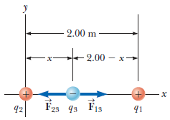Three point charges lie along the *x* axis as shown. The positive charge *q*1 = 15µC is at *x* = 2 m, the positive charge *q*2 = 6µC is at the origin, and the net force acting on *q*3 is zero. What is the *x* coordinate of *q*3?
2. 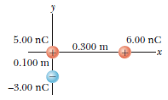Three point charges are arranged as shown in Figure. (a) Find the magnitude and the direction of the electric force on the particle at the origin.
3. 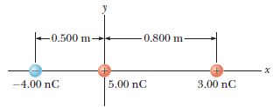Three charged particles are aligned along the *x* axis as shown. Find the electric field at (a) the position (2m, 0) and (b) the position (0, 2 m).
4. In the figure shown, determine the point (other than infinity) at which the electric field is zero.

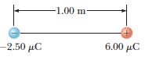

1. Three point charges are located on a circular arc as shown. (a) What is the total electric field at *P*, the center of the arc? (b) Find the electric force that would be exerted on a 5nC point charge placed at *P.*

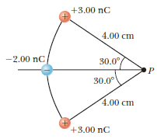

1. Two particles, with charges of 20nC and -20nC, are placed at the points with coordinates (0, 4cm) and (0, -4cm) respectively. A particle with charge 10nC is located at the origin. Find the electric potential energy of the configuration of the three fixed charges.
2. (a) What is the potential at each of the following distances from a charge of 2µC: ***a*** = 10cm and ***b*** = 50cm? (b) What is the potential difference between points ***a*** and ***b***? (c) How much work is required to carry a 0.05µC charge from point ***b*** = 50cm to ***a*** = 10cm? (d) Suppose that a proton is released at ***a*** = 10 cm. How fats will it be moving as it passes a point at ***b*** = 50 cm?
3. Two point charges q1 = +2.4nC and q2 = -6.5nC 0.1m are apart. Point ***A*** is midway between them; point ***B*** is 0.08m from q1 and 0.06m from q2. Take the electric potential to be zero at infinity. Find (a) the potential at point ***A*** (b) the potential at point ***B*** (c) the work done by the electric field on a charge of 2.5nC that travels from point ***B*** to point ***A***?
4. A point charge q1 = +2.4µC is held stationary at the origin. A second point charge q2 = -4.3µC moves from the point x=0.15m, y = 0 to the point x = 0.25m, y = 0.25m. How much work is done by the electric force on q2?